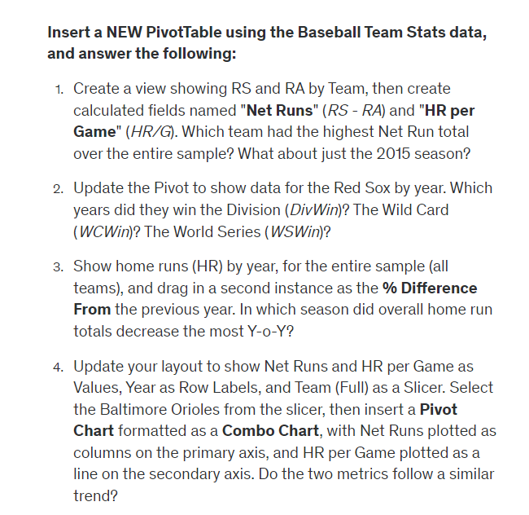

1. New York Yankees 2625, Toronto Blue Jays 221

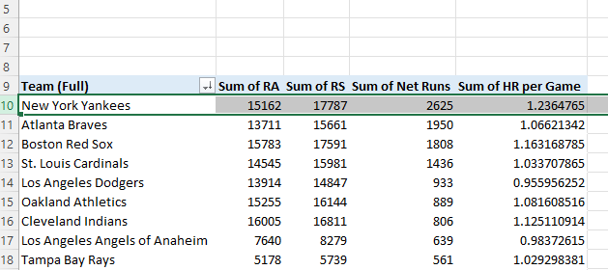

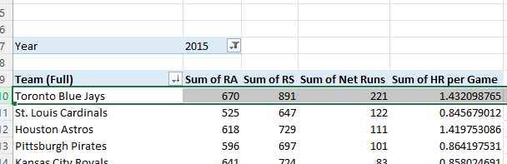

1. For division wins: 1995, 2007, 2013  
   For Wild Card wins: 1998, 1999, 2003, 2004, 2005, 2008, 2009

For World Series Wins: 2004, 2007, 2013

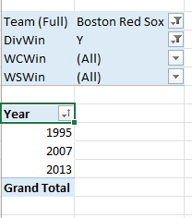

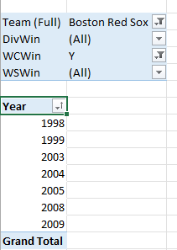

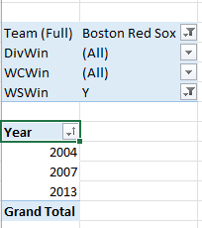

3.2014 -10.19%

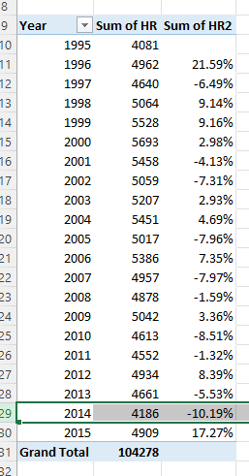

4. YES They follow the trend

